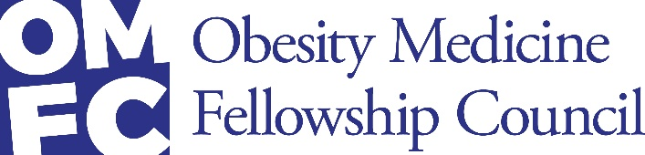

Fellowship Development Program Funding FAQ

- Who is eligible to apply for the OMFC funding?
  - Recently formed Obesity Medicine Fellowship programs and programs in development that will provide full-time training of physicians may apply for this funding.

- What types of costs can the OMFC funding cover?
  - You may request funding for expenses related to the fellowship program. All applications must come with a detailed budget justification.

- How many programs will the OMFC be able to fund?
  - The OMFC has budgeted for support of at least 10 new programs over the next few years.

- Can fellowship programs have more than one fellow?
  - Yes. Fellowship programs can be of any size but the amount of funding from the OMFC is limited to approximately 50% of 1 fellow’s salary for 2 years.

- Can we use all the funding in the first year?
  - No.

- Does my proposed program need to be approved by my institution’s GME oversight committee?
  - Yes. The program needs to be approved by the time of funding, but not by the time of application.

- What is the source of funding for this program?
  - Novo Nordisk has provided a 5-year grant to support this Fellowship Development Program. The funding is in the form of an unrestricted educational grant. The grant funding is being managed by The Obesity Society under the direction of the Obesity Medicine Fellowship Council.
  - The American Board of Obesity Medicine provides in-kind support for the staffing of the Obesity Medicine Fellowship Council.

